A Morphological Local-Contrast Selective Algorithm for Thermal Target Tracking

Raghav Vashist
Manipal University Jaipur
Raghavvashist18@gmail.com

Aditya Mandliya
L&T Precision Engineering & Systems
Aditya.Mandliya@larsentoubro.com

Abstract—High-speed real-time target tracking in operational Electro Optical/Infra-Red systems requires ultra-low latency, deterministic memory usage and strong background clutter suppression. While modern deep learning models provide high recognition rates, their large computational footprint, high memory requirements and complete dependency on dedicated graphics processors make it impossible to implement them on embedded field processors. Here we propose a new lightweight deterministic target tracking approach based on a custom 12 x 12 morphological local contrast kernel $C_{k}$, dynamic background subtraction $B_{t}$ and spatial geometry gating (H). Further Combining active radar telemetry to define the region of interest (Adaptive ROI), the search area is dynamically limited to predicted targets loci, which provides an up to 80–90% reduction in computational load. Implemented as a zero-dependency standalone C++ engine, the proposed algorithm reaches a per frame latency of less than 10 ms (>100 FPS) and memory usage of less than 20 MB on standard CPU environments, providing at the same time false positives elimination related to cloud-sky junctions, ground heat reflection and platform jitters.
Keywords—Thermal Infrared Tracking, Local Contrast Operator, Morphological Filtering, Adaptive Region of Interest, Sensor Fusion, Embedded C++ Optimization.

Introduction
Acquisition systems that make use of electro-optical and infrared (EO/IR) technology must deal with the problem of detecting small and maneuverable objects over wide operational over wide operational distances. The thermal signature in cases where distant detection is required appears as a sub-pixel intensity signal, which is affected by atmospheric absorption and reflection off clouds and ground.

Recent literature has extensively emphasized Convolutional Neural Networks (CNNs) and vision transformers (YOLO, Transformers based trackers). However, in practical cases of embedded defense and autonomous applications, deep learning architectures possess significant engineering challenges, such as

High Latency and high Resource Requirement: Deep neural nets need powerful GPU hardware along with large memory allocation (usually more than 1.5–2.0 GB), leading to frame latency of around 25-35 ms.

Sub-Pixel Target Losses: Feature-extraction down sampling layers within deep learning neural networks tend to drop out small and weakly visible targets using less than 10 pixels.
Deployment Issues: Deployment of deep-learning inference involves extensive use of resource-intensive runtime software (CUDA, PyTorch, TensorRT), making firmware updates difficult and delicate.

In contrast, elementary motion detection approaches that use only frame differencing algorithms have higher false alarm rates (FARs), locking on to clouds in motion, sea spray, or even camera shaking. To fill this gap, this paper proposes a low latency and deterministic tracking solution approach using radar-assisted spatial gating and morphological local contrast calculations. Utilizing the simple C++ matrix operations, the proposed algorithm is free from GPU limitations.

System Architecture & Adaptive search strategy
The underlying approach for designing the new tracking engine is based on Computational Economy using Predictive State Synergy. As opposed to doing spatial transformations of the whole image frame (1920 x 1080 pixels), the processing engine uses motion vectors of the previous frame to create the tracking window.

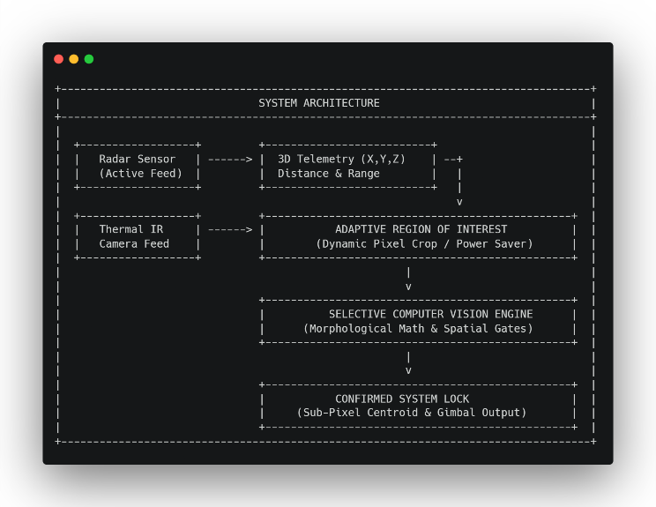

Adaptive Region of Interest (ROI) Dynamics
Processing all pixels in an HD frame is redundant computation that is not required. The adaptive ROI engine will receive raw range and vector data from the on-board radar in order to focus on a target ROI based on the predicted target location.
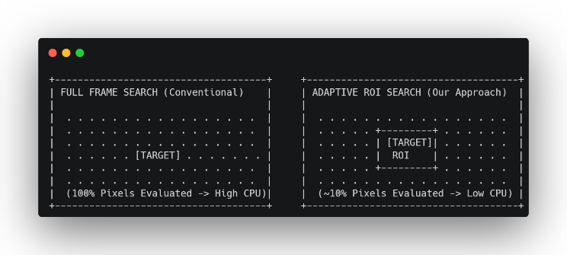

With the formation of visual lock, the size of the ROI is adjusted automatically through dynamic adjustment of bounding limits ($W_{roi}$ x$H_{roi}$) according to the detected spatial extent and velocity of movement of the target. In case there is a temporary loss of visual lock because of cloud cover, the ROI is expanded progressively by the state vectors obtained from the radar.

Mathematical formulation & computer vision pipeline
Conversion of the input raw thermal imagery data frames to a validated target state vector $S_{t}$ occurs based on the master mathematical equation below:

$$S_{t}=H(T_{θ}(C_{k}(\left|I_{t}-B_{t}\right|*K_{close}, S_{t}-1)$$

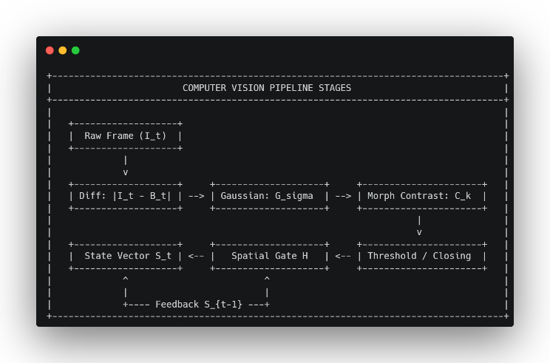

Stage 1: Dynamic Background Subtraction and Noise Suppression
Reduction to separate dynamic objects from non-moving components in the environment (buildings, ground, distant horizons), an algorithm uses a continuously updated model of the background $B_{t}$. The equation looks like this:

$$B_{t}=\left(1-α_{bg}\right)B_{t}-1+α_{bg}I_{t}$$

The value of the background learning rate $α_{bg}$ = 0.008. This relatively low coefficient ensures that stationary and slowly hovering airborne objects cannot get incorporated into the background while slowly adjusting for ambient lighting variations.

The temporal difference $|I_{t}-B_{t}|$is subsequently weighted by a 2D Gaussian smoothing kernel $G_{σ}$:

$$G_{σ}\left(x,y\right)=\frac{1}{2πσ^{2}}exp⁡(-\left(x^{2}+\frac{y^{2}}{2σ^{2}}\right))$$

The convolutions suppress high-frequency noise from the sensors as well as temperature-induced thermal jittering in the electronics without distorting the structural edges of the low-light objects.

Stage 2: Dual Top-Hat Local-Contrast Extraction ($C_{k})$
Depending on the ambient temperature conditions, thermal targets have different polarities; the target is either much warmer than the sky ("White-Hot") or much colder than the background ("Black-Hot"). To accommodate both types at the same time, the system uses the Dual Top-Hat/Black-Hat morphological transformation Ck with K being a 12 x 12 px element. The White-Hot Contrast and Black-Hot Contrasts can be formulated as:

$$W_{hat}\left(f\right)=f-(f ° k)$$

$$B_{hat}\left(f\right)=\left(f∙K\right)-f$$

Where $°$ represents morphological opening and $∙$ represents morphological closing. The computation of the local contrast energy $C_{k}$ involves finding the maximum localized response:

$$C_{k}=max⁡(W_{hat}\left(f_{smooth}\right),B_{hat}\left(f_{smooth}\right))$$

Utilizing a kernel size of 12 x 12 pixels corresponds to normal long range target size (5-50 pixels) and thus enhance target pixels over sky and clouds.

Stage 3: Adaptive Binarization & Gap Closing
The contrast field $C_{k}$ is thresholded using the threshold operator$T_{θ}$, whose intensity is set to $θ$ = 40:

$$T_{θ}\left(p\right)=\left\{\begin{matrix}1, & \text{if }p≥θ \\ 0, & \text{otherwise}\end{matrix}\right.$$

For thermal intensity signals at high detection distances, it is possible for these to split up within each pixel sensor. Morphological closing operation $K_{close}$with a structuring element of 3 x 3 px is used to connect between pixels.

$$A_{\text{binary}}=\left(T_{θ}\left(C_{k}\right)⊕K_{\text{close}}\right)⊖K_{\text{close}}$$

we use $⊕$ to represent dilation and $⊖$to represent erosion, then this process connects disconnected candidate pixels into one blob.

Stage 4: Spatial Extent Gating (H) & Centroid Calculation
To obtain no false alarms, binary blobs need to meet geometric requirements before a system lock is triggered. Spatial gating operator H(A, L) tests the candidate area of the target (A) and the largest extent $L_\max{}$

$$H\left(A,L\right)=\left\{\begin{matrix}1, & \text{if }5≤A≤1000\text{ px} \text{AND} L_{\text{max}}≤80\text{ px} \\ 0, & \text{otherwise}\end{matrix}\right.$$

- Noise Filter (A <5 pixels): Rejects single-pixel noise peaks of the sensor.
- Cloud/Terrain Filter (A >1000 pixels): Rejects massive cloud formations and terrain objects.
- Extent Gate ($L_\max{}$> 80 pixels): Rejects elongated objects like clouds on the horizon, transmission lines, building roof edges.

Experimental evaluation & visual results
The tracker engine was coded in native C++ with compiler optimization enabled for release mode and validated on high-resolution thermal video feeds captured in difficult field environments.

Qualitative Performance Analysis
The visual output below demonstrates the stage-by-stage progression of the pipeline across distinct operational scenarios:

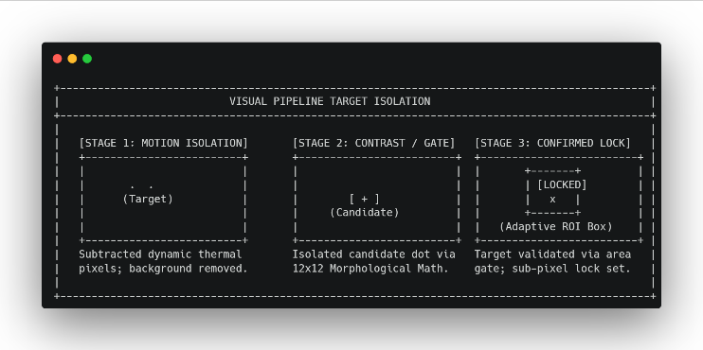

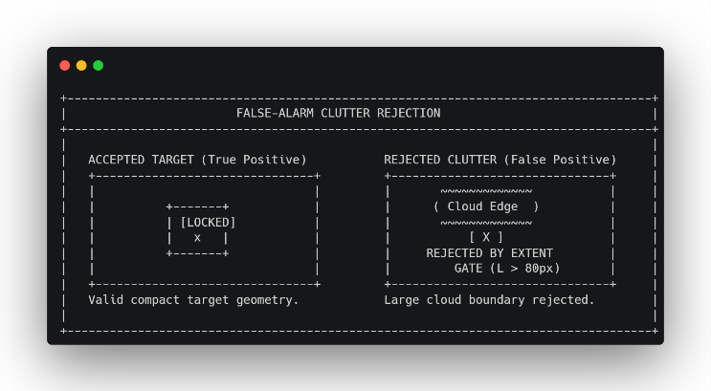

Quantitaive Performance Benchmarking
The performance of the software was measured against that of the commercial baseline trackers implemented with the same set of test cases:
- Memory Footprint: While the suggested tracker engine in C++ uses less than 20 MB of memory space in a system, the corresponding tracker in Python/YOLO takes up about 1.5 GB, and the one in MATLAB uses about 2.0 GB.
- Execution Latency: It was constantly monitored that pipeline execution time per frame was always below 10 MS in regular host processors, thus leading to a speed of more than 100 FPS.
- Hardware Dependency: The algorithm is independent of GPU-accelerated computations and no other third-party library (like CUDA, OpenCV, PyTorch).

System limitatons & future work
Despite the fact that the visual tracking algorithm is quite precise, monocular pinhole cameras have some geometric limitations in estimating the absolute distance $R_{raw}$ for long distances 4 km:

$$R_{\text{raw}}=\frac{f⋅H_{\text{real}}}{h_{\text{pixels}}}$$

where $f$ represents the optical focal length, $H_{real}$ represents the assumed real height of the target, and $H_{pixels}$represents the observed pixel height in the image plane.
In ranges larger than 4 km, the maneuvering target can cover only 2-3 pixels. In such a case, any vibration in the camera platform or pitch change in the physical target causes discrete movements of 1 pixel, causing false range jumps.

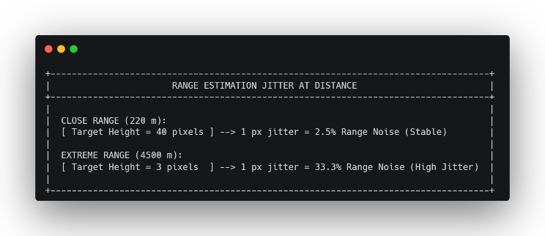

The future development plan to solve monocular range degradation includes:
- Extended Kalman Filter (EKF): To apply kinematic EKF state observation in order to get visual range filtering by means of physical velocity and acceleration limits.
- Deep Thermal Depth Networks: To create lightweight low-bit neural depth estimation modules, trained specifically on thermal infrared profile datasets.
- Integration of Hardware Sensors: To add active telemetry hardware (laser rangefinders) to the physical system, in order to awaken visual tracking in absolute distance measurement.

conclusion
This paper proposed an algorithm that used morphological local contrast for thermal target tracking. The feature of this algorithm is that it replaces deep learning models with efficient 12 x 12 morphological contrast kernels, dynamic background subtraction, and spatial geometry gating methods. The algorithm can be demonstrated to provide processing speed of less than 10ms and requires less than 20MB of RAM for running on a standard CPU. By deploying predictive Adaptive Region of Interest, pixel processing is highly decreased. The spatial extent gating method enables us to filter out false positives caused by clouds and terrain clutter. The software is implemented as a C++ engine that does not have any dependencies.

References
- Derek Bradley, Gerhard Roth, “Adaptive Thresholding Using the Integral Image”
- Y. Dai, Y. Wu, and F. Zhou, "Attentional local contrast networks for infrared small target detection"
- R. E. Kalman, "A new approach to linear filtering and prediction problems"

